A Fund-Raising Golf Tournament
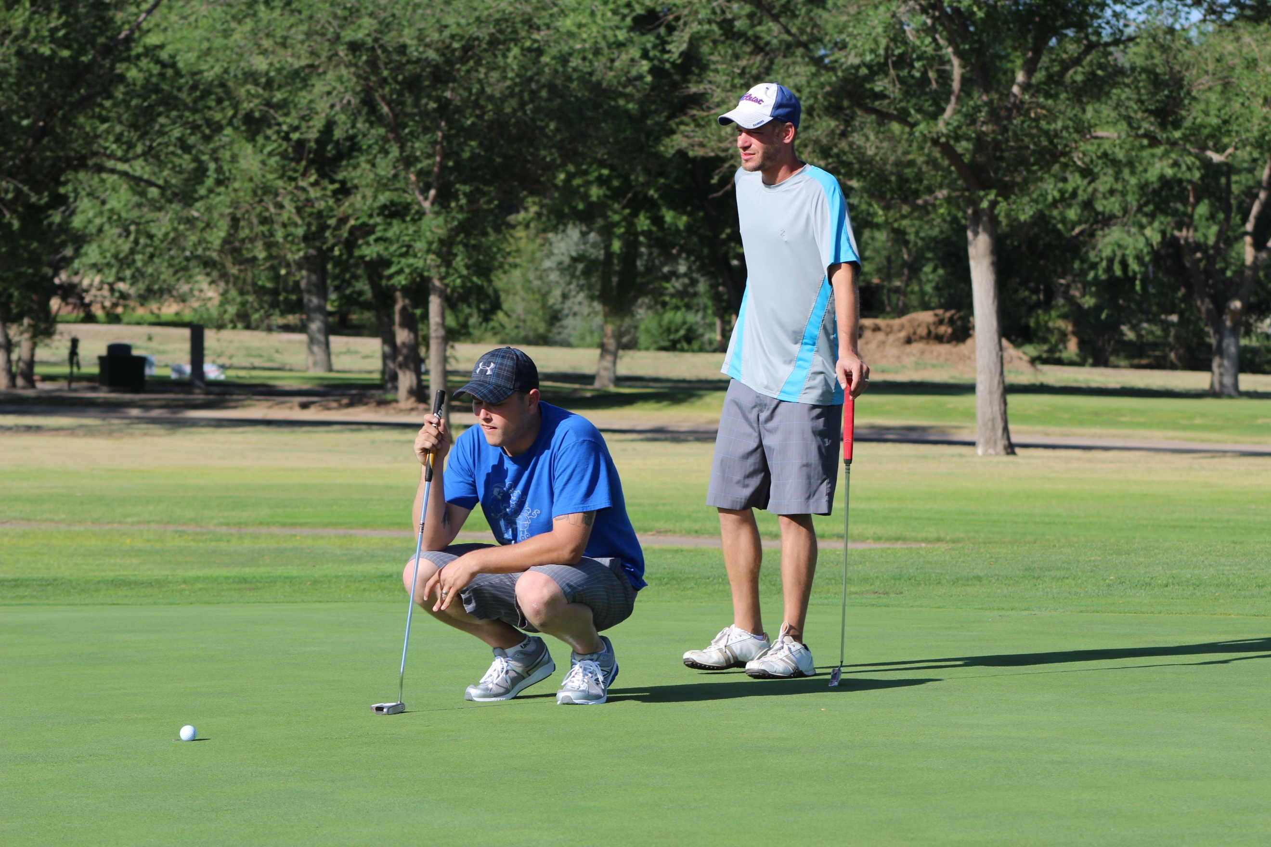
To support the needs of our local veterans’ community
which is open to both military and non-military players

Palo Duro Creek Golf Course
Sat: July 10, 2021
Check in at 08:00 am
Play Begins at 09:00 am

Sponsored By

The Roan Creek Marine Corps League
This Fund Raiser Provides Funding For:
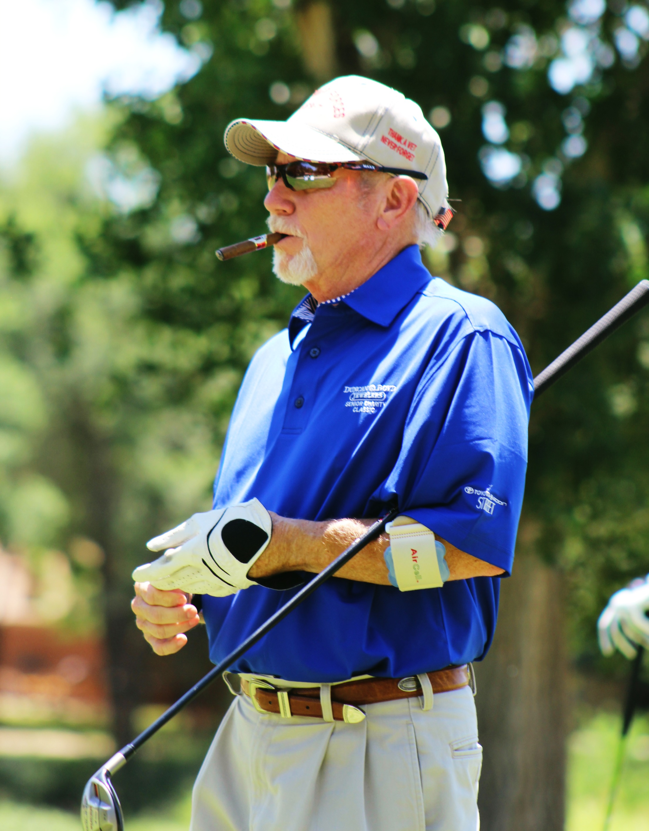
- The Veterans Day Parade
- JROTC Scholarships
- Projects supporting Injured Warriors
- The Panhandle Veterans Financial Assistance Program
Donate Prize and Gift Items:
Grand Prizes: Business Logo Items, Golf Bags, Golf Clubs
Coolers, Chairs, Electronics, Power tools,
Man Cave Items
Door Prizes: Shirts, Caps, Cups, Golf Balls, Towels, Gift
Cards, Hygiene product packs
Grab Bags: Discount Coupons, Pens, Pencils, Freezer
Magnets, Tees

Suggested Sponsorship Levels |  | Point of Contact  Dick Johnson or Howard Wilson  P.O. Box 927  Amarillo, TX 79105  Dick Cell: 806-667-7722  Email: dickj2460@gmail.com  Howard Wilson Cell: 806-676-0729  Email: reta.gobble@sbcglobal.net
Gold Star  $1,000.00 | Receive special recognition as a major supporter, a Certificate of appreciation from the Marine Corps League, and a T-Box Sign
Silver Star  $500.00 | Receive special recognition at the tournament, a Certificate of appreciation from the Marine Corps League, and a T-Box Sign
Bronze Star  $250.00 | A Certificate of appreciation from the Marine Corps League, and a T-Box Sign
Military  Achievement  $150.00 | A Certificate of appreciation from the Marine Corps League, and a T-Box Sign

